

|  |
| --- |
| **Course Code: MGNM801 Course Title: BUSINESS ANALYTICS** |
| **Course Instructor: Mr. Anand Kumar Gupta** |
| **Academic Task No.: 2 Academic Task Title: PROJECT WORK** |
| **Date of submission: 26/12/23 Student Name: SANATAN SNEHI** |
| **Student’s Roll no: RQ2341B50 Student’s Reg. no: 12305532** |
| **Evaluation Parameters**: |

**Learning Outcomes: (Student to write briefly about learning obtained from the academic tasks)**

**Declaration:**

I declare that this Assignment is my individual work. I have not copied it from any other student’s work or fromany other source except where due acknowledgement is made explicitly in the text, nor has any part been writtenfor me by any other person.

**Student’s Signature: SANATAN SNEHI**

**Evaluator’s comments (For Instructor’s use only)** Evaluator’s Signature and Date:

|  |  |  |
| --- | --- | --- |
| **General Observations** | **Suggestions for Improvement** | **Best part of assignment** |
|  |  |  |

Marks Obtained: Max. Marks:

# Project Work

1. **Calculator using operators and if else statements?**

**Ans.**

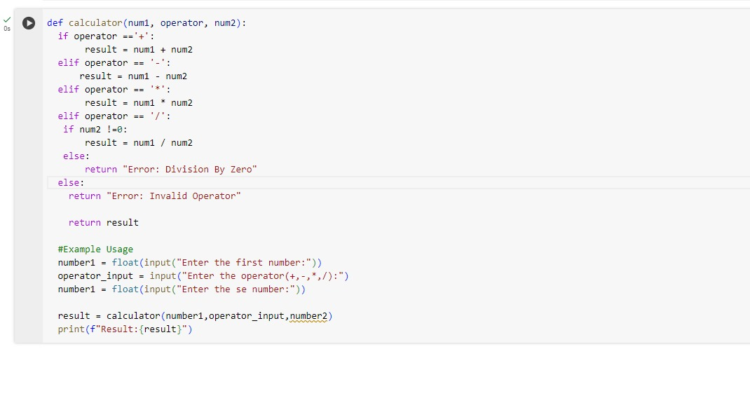

**SALES ANALYSIS**

**Information about the data: -**

**Creating Bar graph using matplotlib.pyplot**

**Creating Bar graph using seaborn**

**Creating Bar graph using plotly.express**

**Pie chart using matplotlib.pyplot**

# Placement Data Analysis

# LINK: https://colab.research.google.com/drive/1WeqhO18JRPcyejfJx62W_Tqxwue6uQS#scrollTo=rPA6MYFWFGs-

1. **Check the first four rows of the Dataframe**

**Ans.**

1. 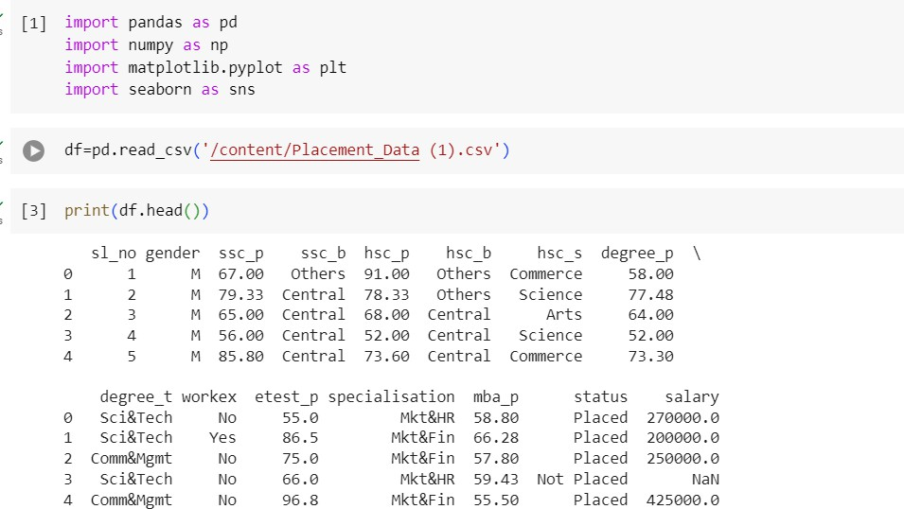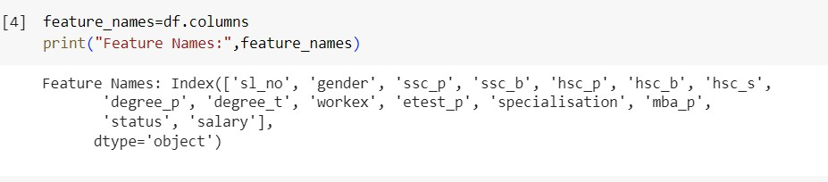**Get all feature names Ans.**
2. 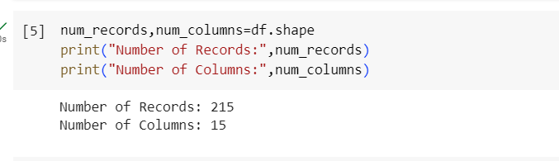**Find the number of records and columns Ans.**
3. 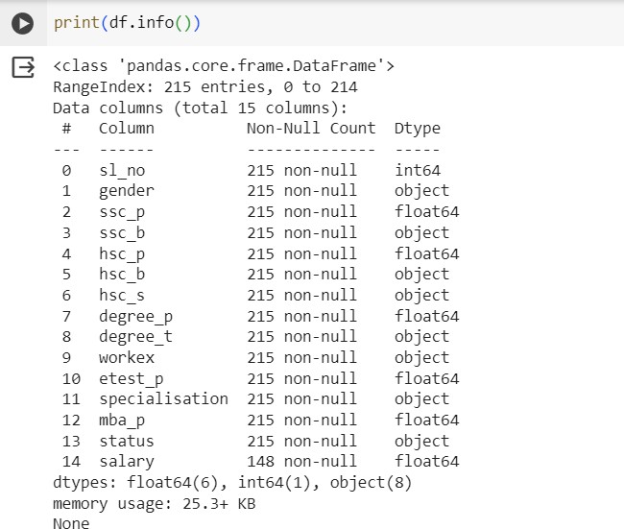**Use the .info() method to find the number of Non Null entries and Data Type of each feature Ans.**
4. 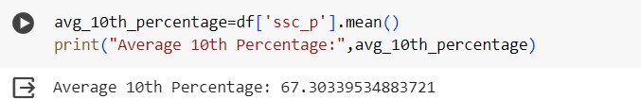**What is the average Secondary Education percentage - 10th Grade Ans.**
5. 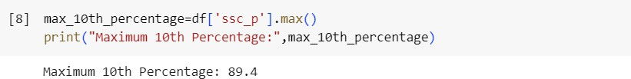**What is the max Secondary Education percentage - 10th Grade Ans.**
6. **How many toppers were there in 10th Grade?**

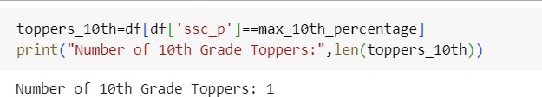Ans.

1. **Is the student who got highest Secondary Education percentage, placed or not?**

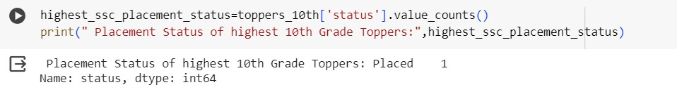Ans.

1. **How many students are placed or unplaced?**

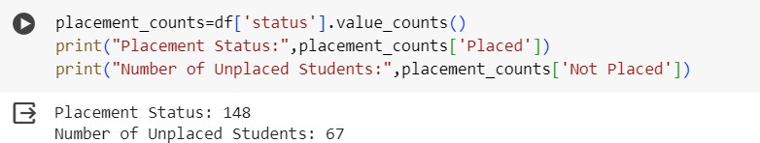Ans.

1. **How many unique degrees are there in the dataset?**

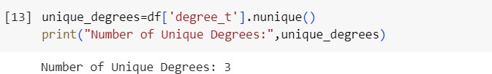Ans.

1. **Is there a correlation between 10th and 12th percentage?**

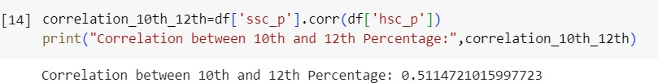Ans.

1. **Find the correlation matrix?**

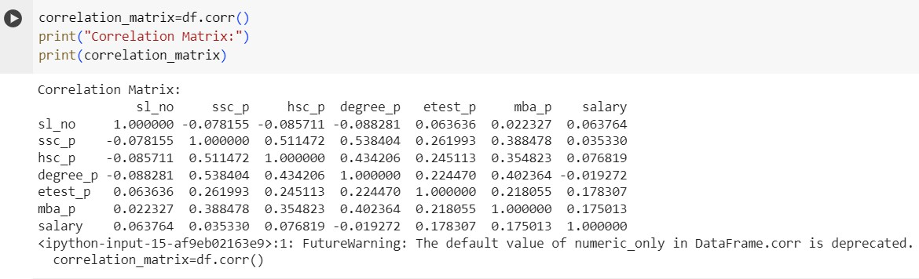Ans.

1. 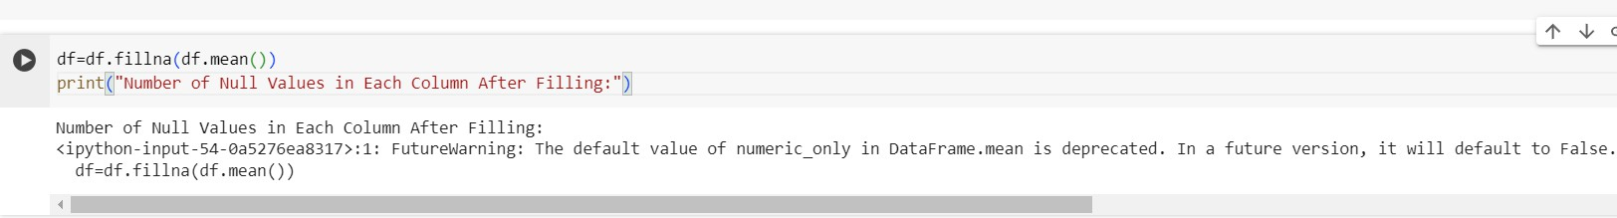**Check number of null values in each column Ans.**

Data Visualization

1. 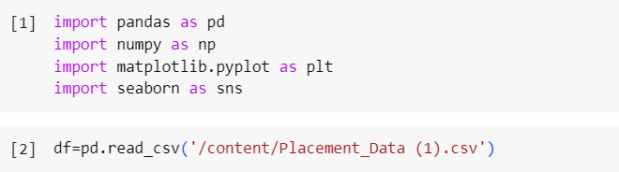**Import matplotlib and seaborn Ans.**
2. 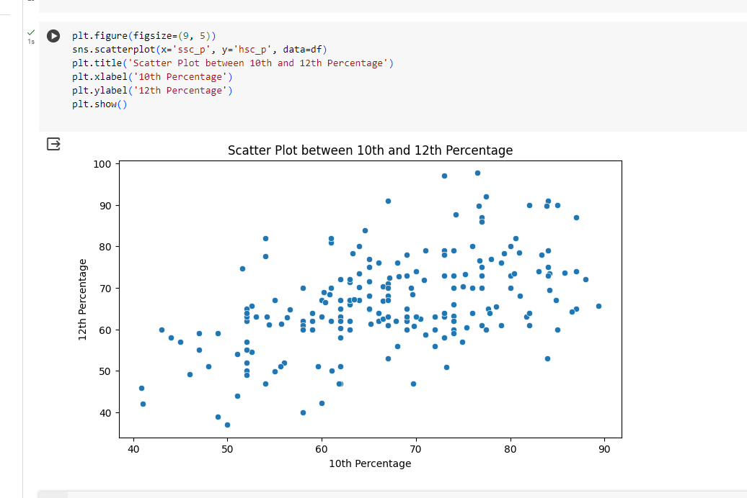**Draw a scatter plot between 10th and 12th percentage with labels and title Ans.**
3. **Draw the scatter plot between 10th and 12th class percentage of students grouped based on placement data?**

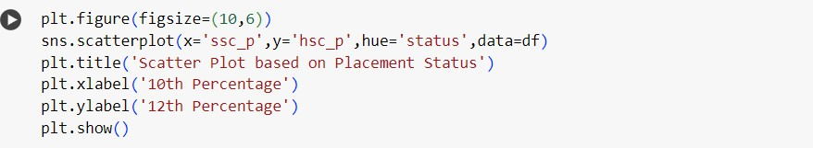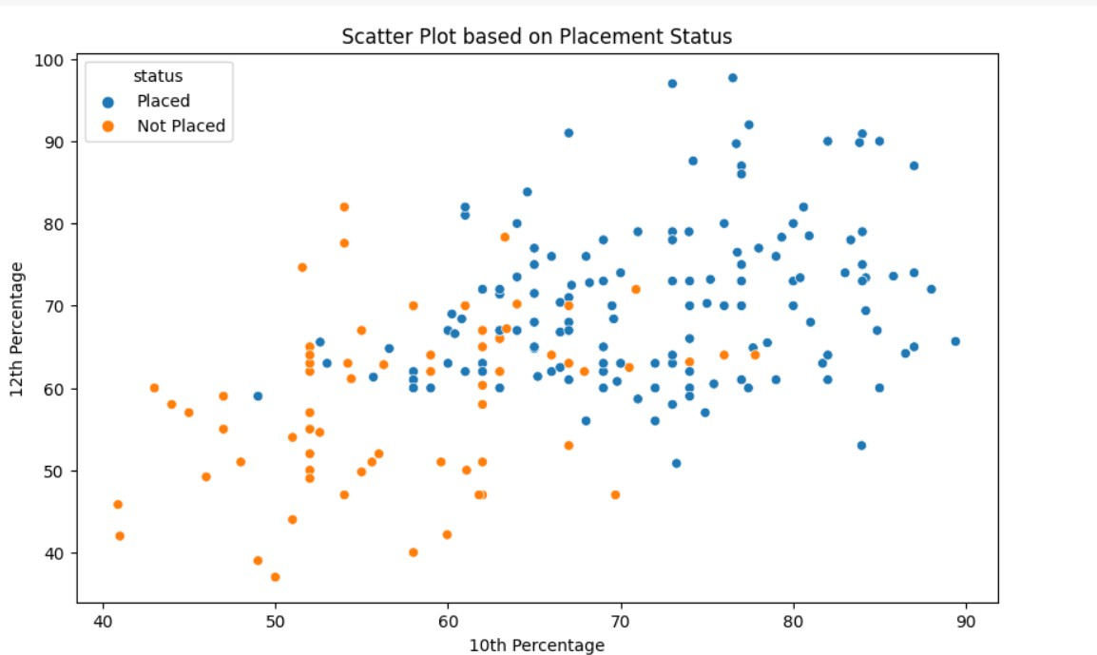

Ans.

1. **Draw a box plot for 10th percentage of the students?**

Ans.

1. **Draw a boxplot for 12th percentage of the students?**

Ans.

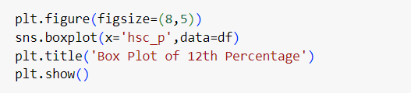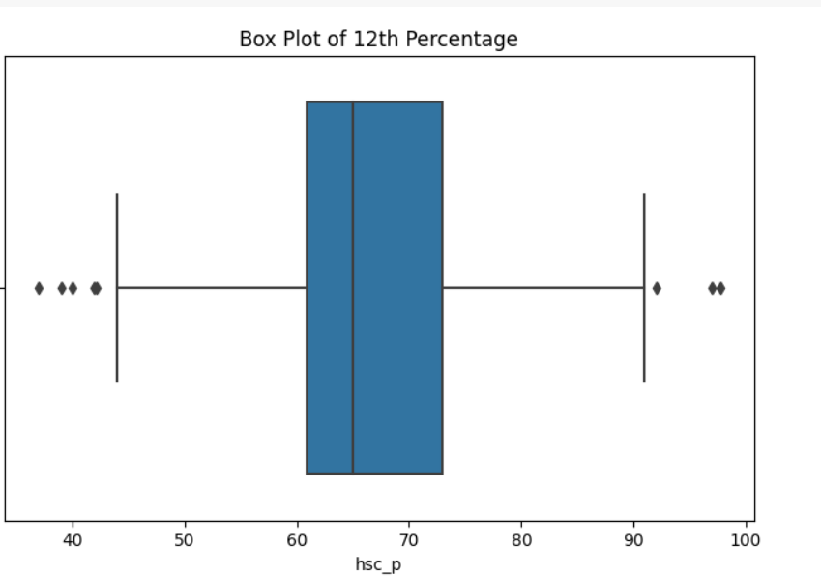

1. **Draw a boxplot for 12th percentage of the students for placed and unplaced students?**

Ans

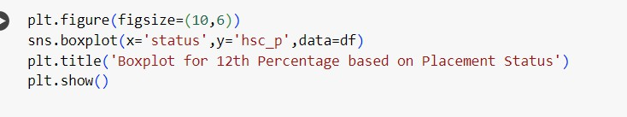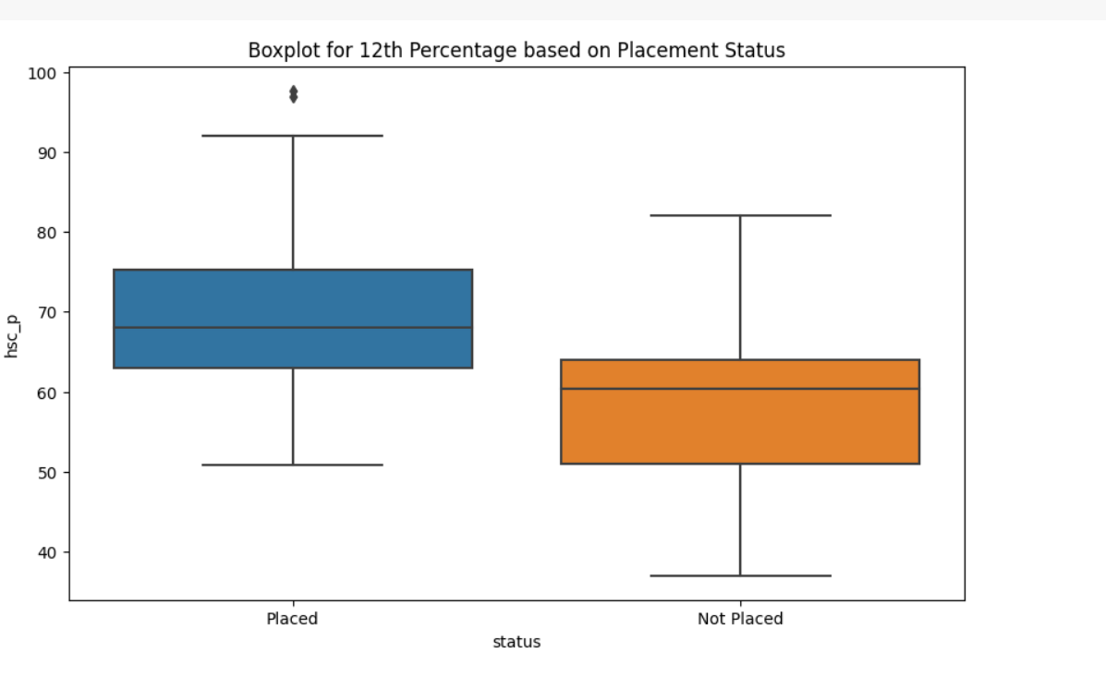

1. **Draw lineplot for 10th, 12th, degree and MBA percentage?**

Ans.

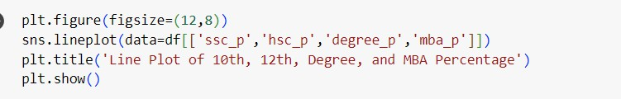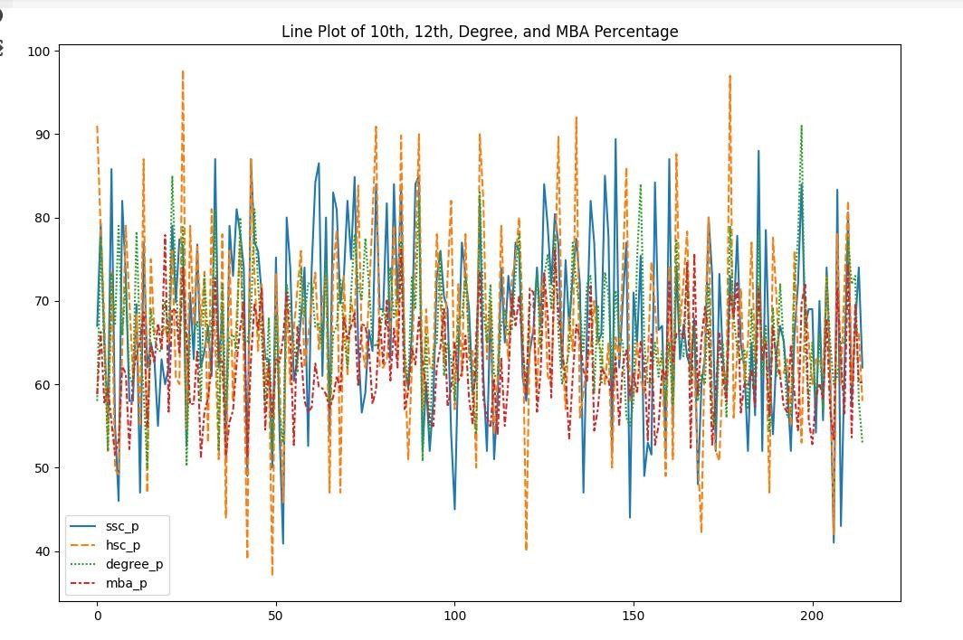

1. **Find correlation between continuous columns?**

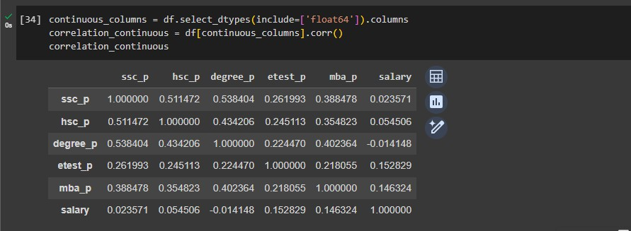Ans.

1. **Draw heatmap of correlation?**

Ans.



